1.DUPLICATE REMOVED

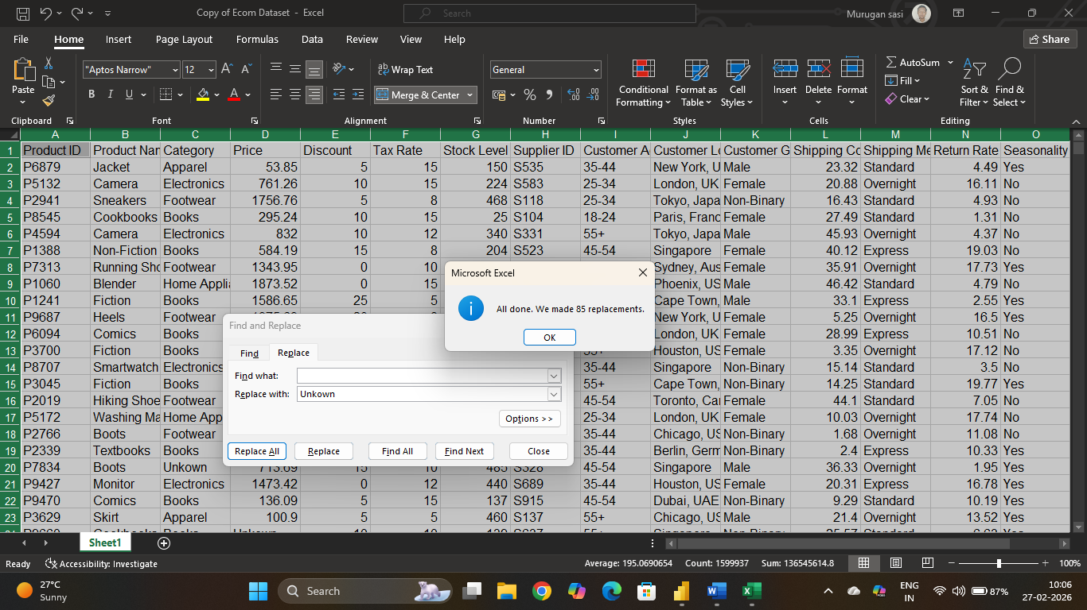

2.BLANK VALUES CHANGED TO UNKNOWN VALUES

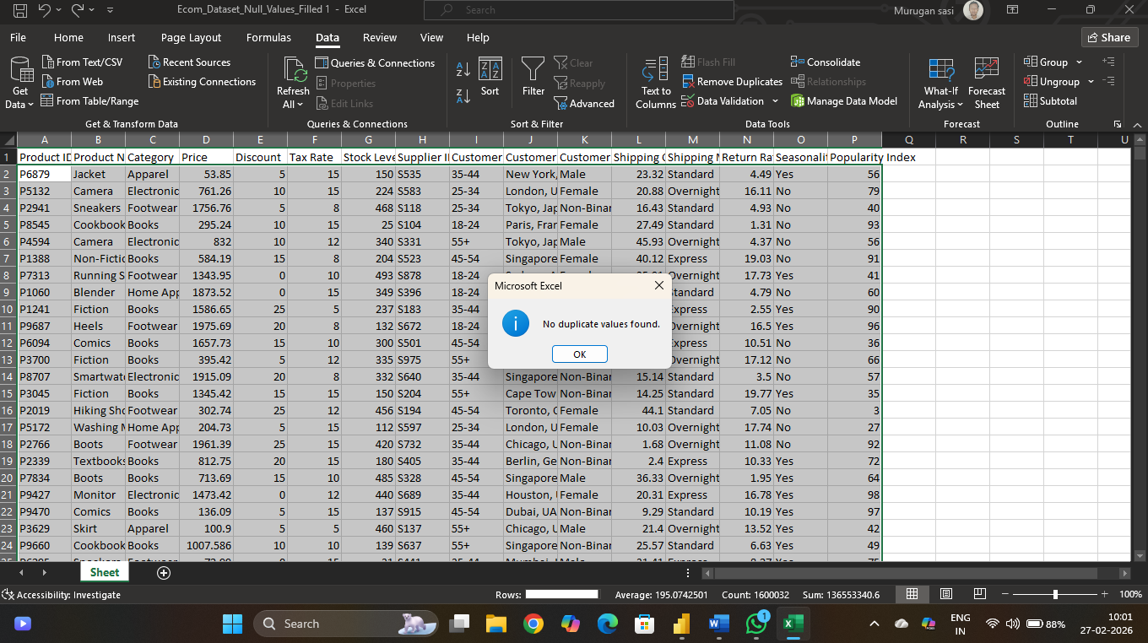

3.POWER QUERY

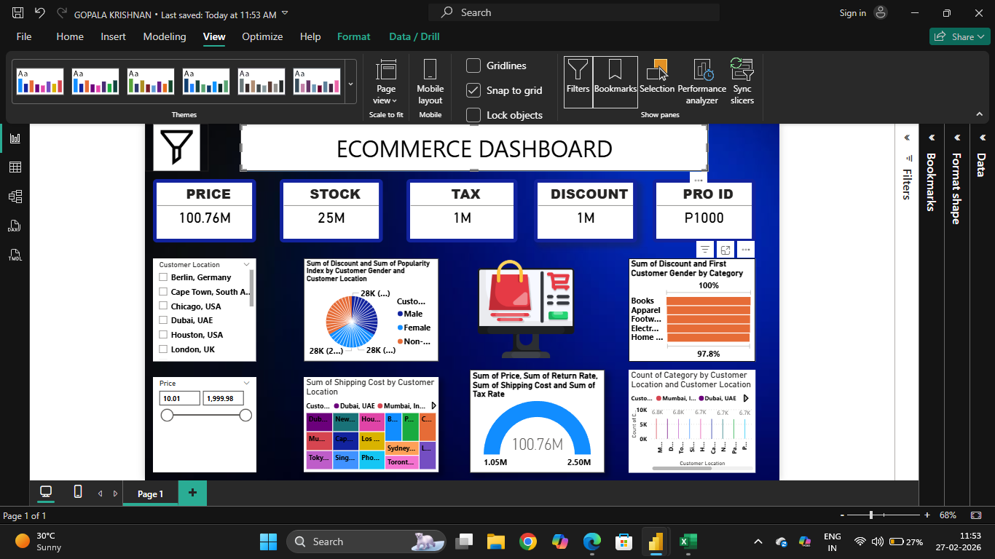

1.Total Revenue is Very High
2.Stock Value is Significant
3.Shipping Cost is Major Contributor

